Best Mobile

Introduction about the Project:

The project I have chosen is predicting the Best Mobile. In this model my main aim was to show if my dataset has any null or missing values and plot the bar charts and histograms for each and every attribute in my dataset.

EDA of my project

I have checked for the null values and plotted the histograms and bar charts for all the attributes in the dataset. The Internal memory, external memory, primary camera, secondary memory, price etc are my main categorical variables. I have chosen these variables to determine which mobile is the best suitable one.

Explanation:

Usually we choose the best mobile set based on the price of different mobiles and the network of mobile, internal memory of mobile, external memory of mobile, ram memory of mobile, primary camera of mobile, secondary of mobile, Wi-Fi LAN feature of mobile, Bluetooth of mobile, battery value of mobile. Since everyone wants to buy a mobile with more features at low price, I have taken that as my condition.

I have shown different brands of mobiles in the following bar graph.

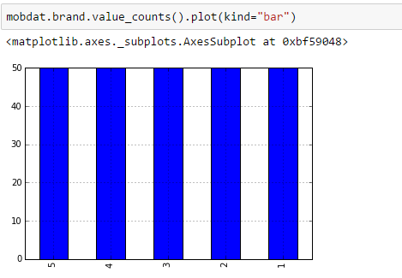

In the following bar graph I have different prices of mobiles.

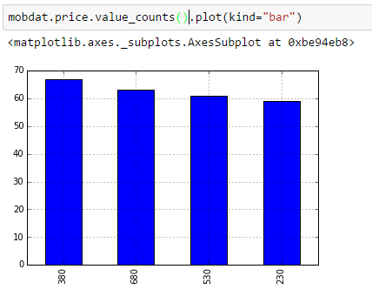

Here I have shown different battery values(mAh) of mobiles.

